Fenland District Council

Homelessness and Rough Sleeping Strategy 2024-29

Draft Version

Table of Contents
Introduction 4
Case Study 4
Life changing and life saving 5
Foreword 6
Purpose and summary of the strategy 7
Vision, definition of homelessness and values 8
Our Vision 8
Definition of homelessness 8
Our Values 8
Homelessness and rough sleeping governance and an overview of the RSI (Rough Sleeping Initiative) partnership 9
About the RSI partnership 9
Sub Regional Homelessness Strategy Group 9
Cambridgeshire Homelessness Operational Group 10
The Housing Board – Cambridgeshire, Peterborough and Suffolk 10
Fenland Supported Housing Forum 11
Strategic review and current context 12
The Local Context 12
Main reasons for loss of settled accommodation 13
Homeless prevention 14
Houses of Multiple Occupation 15
Domestic abuse 15
The Housing register: people waiting for rehousing 16
Homes for Ukraine 16
Dispersal Accommodation for Asylum Seekers 17
Reducing the use of B&B and emergency accommodation 17
Health and wellbeing 18
Historical rough sleeping 18
Operation Luscombe 18
Rough Sleeper Initiative 5 (RSI5) 20
Ending rough sleeping and a housing-led approach 21
No recourse to public funds (Restricted Eligibility) 21
FDC Voluntary Returns Scheme 22
Case Study: FDC’s Enhanced Voluntary Repatriation Scheme 22
Responding to rough sleepers 23
Long term rough sleeper clients 23
Case Study: CGL 24
RSI figures (April 2023 – January 2024) 24
Rehousing options for rough sleepers and those at risk of rough sleeping 25
Case Study: Ferry Project emergency accommodation – Destiny Haven 26
Housing First 27
Case Study: Housing First 28
Changing Futures 28
Case Study: Changing Futures 29
Impact of the Covid Pandemic 31
Key challenges arising from the strategy review 32
Current and future challenges 32
Key challenges 32
Core aims and commitments in the strategy 33
Links to Corporate Business Plan 33
Homelessness prevention 33
Reducing / stopping the cycle of homelessness and sustaining futures 33
Working together 33
Delivery and monitoring 34
Action plan overview 34
Monitoring and review 34

Introduction

In Fenland our partnership strives to prevent homelessness and rough sleeping, it’s in our core values. We are proud of the achievements we have made together for our clients who are at the heart of all that we do.

The case study below sets the scene for our strategy 2024-2029, one of ambition and creativity despite very significant nationwide challenges.

Our strategy sets out the current picture in Fenland, what we have achieved and how together we plan to tackle homelessness and rough sleeping over the next 5 years.

We are very proud of our partnership of ambitious and committed professionals who help to bring about great outcomes for our clients.

This case study celebrates our collaboration with Ferry Project and Places For People, Homes England and Department for Levelling up, Housing & Communities (DLUHC) and the council to enable 6 Modular Homes (Jubiliee Place) under the Next Steps Accommodation Programme for which we are extremely grateful.
Secondly, and most importantly it became home for M who has kindly agreed to share his story.

Case Study

M was being supported by CGL Outreach Team whilst sleeping rough locally. This was a result of his alcohol addiction and subsequent loss of work. M’s alcohol dependency resulted in regular hospital visits, and he also suffers with anxiety and depression. M had full settled status; however, he had no passport or benefits in place. He was also not seeking any support for his alcohol use or mental wellbeing. M only speaks his native language of Polish therefore it was difficult for him to access services.

M was identified as a potential client for Jubilee Place and his progress was discussed regularly at the weekly Rough Sleeper Initiative (RSI) meetings. The decision was made to accommodate M into one of Ferry Project Emergency Accommodation units (Bunker Bed) which gave the bilingual team of RSI workers time to work with M to keep him safe, address his initial basic needs and work on breaking down the barriers linked to his homelessness. This was valuable time decompressing from living on the streets.

M was supported with: Food, Clothes; GP appointments to gain medication for his anxiety and depression; obtaining his passport to help with possible work opportunities in the future; applied for Universal Credit; accessed English for Speakers of Other Languages (ESOL) Courses to help with the language barrier.
A bespoke support plan was also put in place in preparation for his move to Jubilee Place including a budgeting plan, setting up direct debits for service charges, TV licence and council tax, as well as food shopping. M was also referred to CGL drug and alcohol team, for support with his alcohol addiction.
During support sessions and conversations M spoke about his mental wellbeing, M spoke about how he learned to play a guitar at an early age in Poland and used music and singing to cope with his depression. Staff managed to obtain an acoustic guitar for M, that was donated to the Ferry donation hub.

M has expressed keen interest to get back into employment in the future. M is also medicated for his depression and anxiety, he regularly plays his guitar for the other tenants at Jubilee Place in the evenings and weekend barbeques, M is also happy to play for staff and visitors.

M advised his support team that he feels his journey is going well because he is really well supported. He is working on his alcohol dependency, engaging with CGL, mental health support and his GP. M is attending his appointments and has become really engaged. M tells us that he is ‘really happy’.

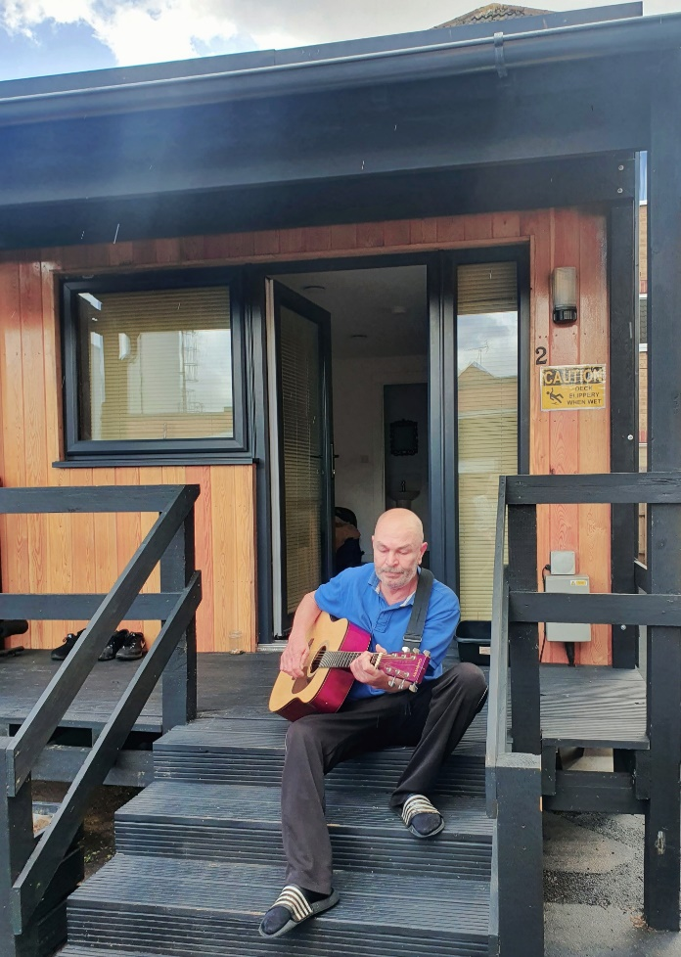

Life changing and life saving

This image not only celebrates all of the hard work that our valuable partners provide in all that they do but offers hope going forward that we can help to prevent homelessness, end rough sleeping and this is the inspiration that this photo of M represents.

Foreword

I am very pleased to introduce the Homelessness and Rough Sleeping Strategy Review and Action from Fenland District Council.

Over the last few years, we have lived through exceptional circumstances with the pandemic, and I am proud to have given my support to the teams to deliver significant opportunities to our clients during this time. I am incredibly grateful for everyone’s efforts and the results of effective collaborative working to prevent homelessness at the earliest possible opportunity and to work towards an end to rough sleeping in Fenland has been truly inspirational.

Our heartfelt thanks to our Housing Options Team and RSI team – namely, FDC, CGL & Ferry Project for their enduring enthusiasm, drive and determination, you have all made a huge different to people’s lives. I would also like to thank all our other partners in the wider homeless system - for example Clarion through enabling the Council to lease 15 properties for temporary accommodation, funding 10 additional homes for rough sleepers through the Rough Sleeping Accommodation Programme, and their enthusiasm and commitment to embrace the highly successful Housing First partnership in Fenland, CHS group and Longhurst for their housing related support service for young people, Amicus and YMCA for move on accommodation to name just a few.

Whilst we have made significant headway to reaching our goal of zero rough sleepers in Fenland, we face significant challenges in homelessness moving forward, with the cost of living crisis and those rough sleepers without recourse to public funds or those who are not yet ready to engage.

We are determined to tackle homelessness and rough sleeping in Fenland through energy and vision in partnership with our teams.

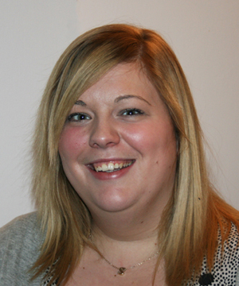

Councillor Sam Hoy
Portfolio Holder for Housing

Purpose and summary of the strategy

The council has worked together with partners to develop this strategy and action plan.

Homelessness doesn’t just mean not having somewhere to live, but a range of issues that contribute to it such as health and mental health, support needs, relationships and life choices, families, looking for a better life within Fenland from abroad and more recently individual circumstances linked employment and affordability of the cost of living.

The council works with the following partners to tackle rough sleeping and homelessness: Amicus Housing Trust, Cambridgeshire County Council, Cambridgeshire Police, Citizens Advice Rural Cambridgeshire, CGL, Clarion Housing, Ferry Project, Cambridgeshire and Peterborough Foundation Trust, P3, Probation Service, Rosmini Centre, Salvation Army, YMCA Trinity, Cornerstone, Longhurst Group, CHS Group and My Space.

“Homelessness is everyone’s responsibility”

Our aim is to prevent homelessness wherever possible. We can only achieve this by working collaboratively and successfully accessing central government funding to provide resources to provide a range of options for our clients.

Our strategy is broken down into 6 segments:

- Vision, definition of homelessness and values
- Homelessness and rough sleeping governance. This includes an overview of the Rough Sleeping Initiative (RSI) partnership
- Strategic review and current context
- Key challenges arising from the review
- Core aims and commitments within the strategy
- Delivery and monitoring

Vision, definition of homelessness and values

Our Vision

Our vision as a partnership is to prevent homelessness and eliminate rough sleeping as soon as possible.

Everyone has a right to a home and that is what we are striving to achieve together.

Definition of homelessness

The council and its partners are committed to working together to end rough sleeping in Fenland. We summarise our definition of homelessness as where someone:

- Has no accommodation available to them in the UK or abroad
- Has no legal right to occupy the accommodation
- Lives in a split household due to availability of accommodation for whole households
- Is where it is unreasonable to continue to occupy accommodation
- Is experiencing violence from any person
- Is unable to secure entry to their home
- Lives in a moveable structure but has no place to put it

It is the aim and ambition of this strategy to:

- Ensure no one sleeps rough or lives in places which are not designed as a home, including tents, vehicles, squats or non-residential buildings.
- Anyone staying in temporary accommodation has a Personalised Housing Plan (PHP) identifying next steps, this also includes detail about support.
- Everyone who is threatened with homelessness (56 days or sooner) is provided with the advice, assistance and support needed to prevent homelessness where possible.
- For those leaving prison and survivors of domestic abuse, care leavers and Armed Forces Veterans to work together with partners to ensure a smooth transition and avoid homelessness wherever possible

Our Values

Our rough Sleeping partnership agreed the following values;

- Partnership – we work better together and achieve better outcomes for our clients with our unique and specialist skills, preventing homelessness where possible. A “one team” culture
- Energy – We bring our energy to get things done and motivate each other
- Ambition - We are forward thinking and creative to find solutions
- Commitment – we are bound by our partnership to work towards ending homelessness together and putting our clients at the centre of what we do

Homelessness and rough sleeping governance and an overview of the RSI (Rough Sleeping Initiative) partnership

About the RSI partnership

The RSI partnership was formed in 2019 following investment from central government to help alleviate rough sleeping. The partnership has since broadened and includes links to multiple charities and statutory organisations including the council’s Housing Options team. This was particularly important in 2020 with the pandemic, we already had the partnership infrastructure to respond proactively and so successfully for our clients.

Members of the RSI include:

- Amicus Trust
- Clarion Housing
- Cambridgeshire Constabulary
- Cambridgeshire County Council - Housing First
- Cambridgeshire & Peterborough Foundation Trust (CPFT)
- Change Grow Live (CLG) Outreach and Tenancy Sustainment & CGL Drug and Alcohol Services
- Ferry Project
- Fenland District Council - Housing Options Team, Private Sector Housing team, Accountancy team
- Housing First (Cambridgeshire County Council)
- Housing Options team (FDC)
- Rosmini Centre
- Salvation Army

Sub Regional Homelessness Strategy Group

Reporting to the Cambridgeshire Regional Housing Board, this partnership across Cambridgeshire, Peterborough and West Suffolk meet monthly to work collaboratively on cross border issues. Their aims and objectives are to:

- Share good practice
- Explore opportunities for joint working across the sub-region. Developing opportunities for improving existing services and providing
- Jointly engage with other services to improve working practices affecting homelessness and the prevention of homelessness
- Monitor and provide input into linked groups and action plans i.e. the sub-regional housing priorities
The group also links with other statutory partners joint working protocols, including Criminal Justice and Housing protocol, Care leavers protocol, 16 & 17 year olds protocol, Mental Health, Housing and Substance Misuse protocol.

Cambridgeshire Homelessness Operational Group

The Cambridgeshire Homelessness Operational Group are responsible for taking forward operational tasks across Cambridgeshire and Peterborough.

The group meets quarterly to ensure cohesive approach to recording data and improving effective ways of working to benefit our customers. There are links here to Home-Link, the county wide procured Choice Based lettings Scheme.

The Housing Board – Cambridgeshire, Peterborough and Suffolk

The Housing Board is a senior officer group of local authorities, housing providers and partner agencies working collaboratively strategically and operationally.
Since 2002 the Housing Board has worked collaboratively with partners to identify issues, gather data, explore solutions and implement change, sharing learning and experience across our housing market area around the Board’s priorities.

Priorities for the board

Housing is key to everyone’s health, well being and employment opportunities. Good quality housing is also vital for a thriving local economy. Across Cambridge, East Cambridgeshire, Fenland, Huntingdonshire, Peterborough, South Cambridgeshire and West Suffolk, the Housing Board works with partners to share learning and experience to:

- Deliver new homes and communities to support economic success
- Ensure homes and services support better health and well being
- Improve standards in existing homes and encourage best use of all homes
- Identify and meet housing need, extend housing choice and tackle homelessness
- Understand housing costs and the cost of living crisis in our area, and tackle the impact of both
- Support housing with a low impact on the environment, which is energy efficient and which limits our carbon footprint.
From 2022, these are the Housing Board’s six priorities, all of which will only be achieved by working closely with our partners. Many issues are very local and are best addressed by district councils, housing partners and communities themselves – but some are shared across a wider area and this is where collaboration can really help. Some partners have a role and a business plan which covers a broad area and cuts across district boundaries.

More information on the board is available at: Cambridgeshire & Peterborough Insight – Housing & Planning – Housing priorities (cambridgeshireinsight.org.uk)

Fenland Supported Housing Forum

The Fenland Supported Housing Forum was established by Cambridge Housing Society (CHS Group) to pull together the organisations in Fenland who are providing housing support for people who are either homeless or at risk of homelessness, with the aim of working together to provide a more comprehensive, collaborate service.
The terms of reference will identify the aims of the Fenland provider forum and record the basis on which the organisations will work together.

Membership

The organisations represented in the forum are:

- Fenland District Council
- CHS Group
- Longhurst Group
- Ferry Project
- YMCA
- Amicus Trust
- My Space Housing Solutions
Purpose

- Increase communication between members and other organisations to ensure service is delivered in the best interest of those using it
- Develop/ improve pathways both internal and external to ensure a better transition to those using the services
- Identify and work with other organisations (local authorities, health and voluntary organisations) to improve the resources / support available
- Work in partnership to support pathways for individuals maintaining accommodation to reduce the cycle of homelessness
- Identify any potential risk or issues that could impact the current services
- Identify any gaps in provision and work together to explore ways of addressing these
- Develop / Share best practice and resources to ensure a more cohesive approach
- Support a whole system approach to tackling homelessness

Strategic review and current context

Our homelessness and rough sleeper service has adapted to significant change over the past few years following the introduction of the Homelessness Reduction Act 2017, the pandemic and welfare reforms.

The number of approaches for housing advice has increased significantly since 2021/22 to 2022/23 as shown in the charts below.

The Local Context

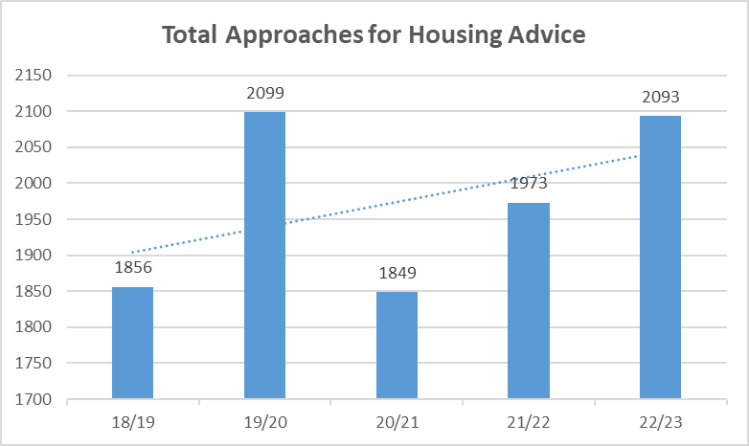

The graph above shows total number of approaches for housing advice have increased significantly by 12.77% since 2018 and particularly since the 2020 Covid-19 pandemic there has been an increase in approaches for housing advice from households with a family commitment by 20.49%.

This has had a significant impact on demand for emergency interim accommodation leading to more households not only requiring B&B as emergency interim accommodation but staying there longer than we would like before moving into other types of interim accommodation or permanent rehousing.

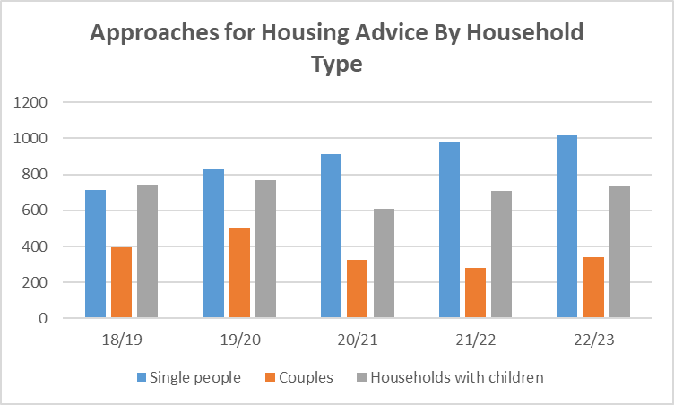

Data shown in chart: TBC

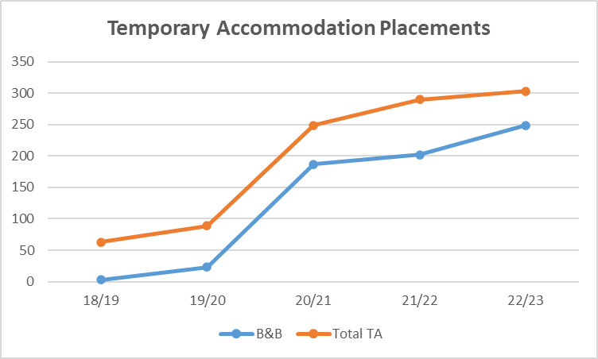

Data shown in Temporary Accommodation Placements chart: TBC

Main reasons for loss of settled accommodation

The reasons for homelessness are largely similar to recent years, however, increased in volume of presentations. In particularly, most approaches coming from family no longer willing to accommodate up from 360 cases in 21/22 to 371 in 22/23.
All other areas are increased, including relationships ending (non-violent), ending of private rented accommodation up from 253 in 21/22 to 322 in 22/23, and a worrying increase in domestic abuse up from 106 in 21/22 to 148 in 22/23.

The only area to decrease slightly was ending of private rented tenancies (not assured shorthold tenancies). A possible reason for this was the legacy of restrictions on ending tenancies during Covid.

Table depicting main reasons for loss of settled accommodation

Reason | Year 2022/23 | Year 2021/22 | Year 2020/21
Family no longer willing to accommodate | 371 | 360 | 350
Relationship with partner ended (non-violent) | 281 | 275 | 234
End of private rented tenancy – assured shorthold tenancy | 322 | 253 | 145
Domestic abuse – victim | 148 | 106 | 132
End of private rented tenancy - not assured shorthold tenancy | 136 | 148 | 75

Homeless prevention

The Council’s Housing Options Team successfully prevented 275 households from becoming homeless in 22/23.

We successfully rehoused 98 households into the private rented sector in 22/23
The Council offers financial incentives to private sector landlords by way of deposits, enhanced deposits or rent in advance. In an ever-competitive market, it is important to adapt our services to meet the ever-changing climate.

The council provide funding to Cambridgeshire Rural CAB to provide advice and guidance to all residents of Fenland. Their expertise in debt advice and financial matters has made a very positive impact on individuals circumstances enabling them to maximise their income by carefully working through financial statements and negotiations with lenders.

The council is engaging in an Early Help Hub pilot. The council is receiving funding from the North Place Partnership Board to provide the triage administrative function for an Early Help Hub across the public sector system and Voluntary & Community Sector (VCS) . The aspiration is to receive early up stream notifications of households and individuals in need who are either out of work or off work sick. Experience from a similar approach in South Norfolk shows how with a much broader range of partners across the public and VCS system, housing insecurity issues will become known to the Council earlier for example, a sofa surfer engaging with the GP, to enable support to be provider before that person loses accommodation and rough sleeps.

The Council’s Private Sector Housing Team assist by ensuring properties are safe for clients to occupy before deposits or rent incentives are paid. The team also offer support and guidance to landlords and agents who require it and conduct a mandatory licencing scheme for house of multiple occupation (HMO).

Houses of Multiple Occupation

A House of Multiple Occupation (HMO) is a property rented out by at least 3 people who are not from 1 'household' (e.g a family) but share facilities like the bathroom and kitchen.

Anyone who owns or manages a HMO (including landlords and letting agents) in the Fenland district must have a licence from us if their property is occupied by 5 or more people, occupants form 2 or more households (a household are members of the same family living together) and occupants share 'basic amenities' (e.g kitchen, bathroom)

There is significant demand for well-managed, well maintained and safe HMO’s in Fenland, particularly for those under 35 years of age where the Local Housing Allowance will often only cover the rent of a room in a shared house (HMO) as opposed to a one bedroom flat.

The council work closely in partnership with Anglia Revenues Partnership (ARP) who manage the Housing Benefit System on the Council’s behalf. ARP also manage a Discretionary Housing Payment (DHP) fund, that has provided deposits, paid rent arrears, the total DHP spend in 2022/23 was £106,032.

Domestic abuse

The Housing Options team have seen an increase in cases over the past two years, (148 cases in 22/23). We work closely with the IDVAS (Independent domestic abuse advisors) via Cambridgeshire County Council along with specialist support organisations.

The Council is currently undertaking a Domestic Abuse Housing Accreditation (DAHA). This involves evidencing all of our work across the council relating to our response to domestic abuse and being externally assessed that we adequately meet the criteria. We have engaged with survivors with lived experience to help shape our procedures to benefit the needs of future clients through this process. We expect the assessment to be undertaken during 2024.

Case Study

B approached the Housing Options team for help. She was receiving assistance from Social Care who were involved with her young son following concerns about safety in the home.

B was being abused both physically and emotionally by her ex-husband, the abuse also involved stalking and being tracked by him.

B Had a tenancy outside of Fenland, it was in her name, the advice from the social worker was for B to move to another area.

The Housing Options team worked closely with B’s Social Worker, a temporary move was arranged via extended family who could also provide support. the extended family were the temporary legal guardian of B’s son.

The Housing Options team worked collaboratively with both B and her social worker, IDVA (independent Domestic Violence Advisor) and extended family to find a safe alternative property for B to live with her son independently.

Via the Homelessness route, B successfully bid for a new home via Home-Link and has settled safely with her son.

The Housing register: people waiting for rehousing

Year | People waiting for rehousing
2019/20 | 1066
2020/21 | 1359
2021/22 | 1435
2022/23 | 1744

For Clarion lets, in 2021/22 the number of people waiting was 315. In 2022/23 it was 247.

It is clear from the statistics that there is growing demand for social housing in Fenland.

The number of relets have decreased between 21/22 and 22/23. This has been due to an increase in checks and balances with Registered Providers (RP) tenants in response to the tragic circumstances around the death of Awaab Ishaks due to damp and mould impacts. This led in one RP circumstances an increase of repairs by one third from the previous year. Prioritising action in this area led to demands on maintenance teams and the ability to quickly do work on voids to make them available to relet. This caused a significant reduction in relets (by 115 from the previous year). This reduction has resulted in a silting up of temporary accommodation.

Void work timescales are now being addressed which will help assist moving homeless families into settled accommodation alongside an increase in new provision. In March 2024 there was an identified pipeline of circa 900 new affordable rented homes an additional 400 affordable ownership products and a further 536 affordable homes in negotiations. This pipeline is seen as essential in speeding the flow of presentation for homelessness.

Homes for Ukraine

The council has been operating a Homes for Ukraine Scheme since February 2022. Currently there are around 100 guests living with hosts in Fenland. The council has worked hard to protect and support both hosts and guests through safety checks, welfare checks and administration of the scheme as a whole.

The focus of Phase 2 was to undertake a survey to ascertain the move on requirements of the current guests and support them with partners into alternative settled homes where this is requested. Our aim is to prevent homelessness wherever possible.

As of March 2024, 9 families have become homeless due to being asked to leave by hosts, or families (under the Family scheme).

The costs of the scheme including temporary accommodation and funding for deposits is funded via Central Government. The same services are offered to all clients across our service.

Dispersal Accommodation for Asylum Seekers

As part of a national scheme, the Home Office are procuring temporary accommodation for asylum seekers whilst they wait for the outcome of their claims to remain in the UK. All council areas are part of the scheme and to enable the smooth running of the scheme within Fenland and to help maintain cohesion, the council has requested that areas such as Wisbech and the surrounding villages are not selected for this initiative.

Reducing the use of B&B and emergency accommodation

The council has a portfolio of temporary accommodation to provide emergency homes to our homeless clients.

We have a mix of accommodation from a hostel to a number of self-contained leased properties from our partners at Clarion Housing.

Demand for our service and therefore accommodation is increasing. The council accommodates individuals and families initially in bed and breakfast accommodation.
We realise that this is both short term emergency accommodation and not suitable for families over a prolonged period, we took the decision to lease additional properties from Clarion Housing and to also look for additional units, taking a total to 56 by August 31st 2024.

To help get to 56 the council has successfully bid to central government under the Local Authority Housing Fund (LAHF). 33 properties have been purchased on the open market, 8 to provide temporary homes to rehouse Ukraine families, 5 for Afghan families and 20 for general needs. Once clients have moved on and there is no more demand for Ukrainian and Afghan families, these properties will revert to general needs use, and therefore significantly reducing bed and breakfast accommodation use.

Feasibility to provide better and more cost-effective solutions for single households and couples needing emergency interim accommodation is underway.

Health and wellbeing

Homelessness and rough sleeping can seriously impact on your health and wellbeing. According to the charity Crisis, the average life expectancy of a man is 47 and 43 years for women. This is compared to an average of 77 years in the general population with men living to around 74 years and women to 80 years. Life is cut short by almost 50%.

Historical rough sleeping

Many of our rough sleepers both currently and historically are migrants, mostly from Lithuania. Fenland has attracted migrant workers to the district since 2003/04, often coming to Fenland to take up agricultural work in the fields and also food processing in factories. The majority of Fenland’s rough sleepers are male and aged between 25 and 65, a significant number being foreign nationals from Eastern Europe, Lithuania, Latvia and Bulgaria.

Frequently, accommodation (HMO’s) is provided with work and when work dries up or workers are no longer needed this can result in homelessness and rough sleeping.

The council along with the Police established Operation Pheasant in 2012, a project to tackle human trafficking and exploitation and modern-day slavery, linked to the private rented sector in the town of Wisbech. The council’s Private Sector Housing Team link in with Rough Sleeping and Housing Options Team, this approach ensures sharing of relevant intelligence and protects our clients.

The partnership has been cited nationally as best practice and has won three national awards.

Operation Luscombe

The Police in partnership with the council, launched Operation Luscombe in September 2022. The purpose of the initiative is to target street drinkers and people begging in Wisbech. There is cross over with the council’s RSI project and the infrastructure we have created accommodated this new initiative.

The project involves a partnership response to street drinking and begging, with a suite of actions, but most importantly, linking individuals into the Hub and providing an opportunity to tackle some of the broader issues including housing, health, mental health and drug and alcohol advice. There are consequences for non-engagement including fines and Community Orders.

The persons referred are predominantly those engaged in anti-social street drinking and/or begging. They include a mixture of homeless persons and those that have their own accommodation.

The different stages are:
- Green – An informal warning and an invitation to attend the safeguarding hub
- Amber – A community protection warning (With suggested conditions) with an invitation to the safeguarding hub
- Red – A community protection notice (With enforceable conditions) with an invitation to the safeguarding hub
- Blue – Prosecution for breaching the CPN and an invitation to the hub
There are 65 persons on the Operation Luscombe cohort, the table below shows the breakdown as of 05.02.24:

Stage | Current Number | Total Number of hub appointments | Attended Hub | % Attended Hub
Blue | 4 | 4 | 3 | 75%
Red | 1 | 5 | 3 | 60%
Amber | 7 | 12 | 4 | 33%
Green | 53 | 65 | 9 | 14%
Totals | 65 | 86 | 19 | 22%

The Hub

The Hub meets every second Monday at the Ferry Project. It is attended by the following partners:

- Ferry Project
- Housing first
- Fenland District Council (Homeless Outreach / community safety team)
- CPFT Mental health nurses (FALT team)
- CGL – Eastern European Outreach
- CGL – Drug and Alcohol misuse specialists
- Department of Work and Pensions enhanced support team.
- Counting Every Adult Team
Hub attendance by those who are referred sits at 22.89%. However, where safeguarding issues have been identified, the partnership will look to take action whether or not the referred individual attends – for example: home visits, appointments being made.

Enforcement

The Police have prosecuted four persons under the Luscombe process. A summary:

- One female persistent beggar was prosecuted for breaching a ‘Red Ticket’. She was fined and issued with a Criminal Behaviour Order to curtail her begging (This female was unknown to services locally, she was given support and we also uncovered domestic abuse concerns that were dealt with.)
- One male persistent beggar was prosecuted for breaching a ‘Red Ticket’, he was fined and we also supported the Local Authority with evidence gather to secure a ASB injunction
- One female persistent beggar was prosecuted for breaching a ‘Red Ticket’, she was fined (£1000), we applied for a Criminal Behaviour Order but before this was issued she was imprisoned for three years for an unrelated matter
- One male drinker was fined after breaching the PSPO and becoming aggressive towards police when challenged. He has not been found drinking since and has been engaging with CGL

Successes

There are many individual success stories where we have worked together to prevent offending. A male on the cohort has been supported out of a shed in the town centre where he had lived for over a year. He engaged with services and is no longer sleeping rough.

Another recent proactive effort includes a homeless male with mental health concerns. He is very untrusting of services, and we have worked together to build his trust. The Ferry project have provided a wash kit and mental health have opened up their offices to allow the male to wash there. We are slowly making progress and he is starting to engage – hopefully in an effort to prevent future offending.

Rough Sleeper Initiative 5 (RSI5)

The Council has always been proactive in seeking additional resources to enable specialist services to be established in Fenland.

In 2022, the council was successful in a £1.186m fund from Department for Levelling up, Housing & Communities over 3 years called Rough Sleeper Initiative 5.
In partnership with Change Grow Live (CGL) and Ferry Project, the fund provides support workers, tenancy sustainment officers, a Hub, outreach workers and a coordinator to provide a holistic service to anyone at risk of rough sleeping or actually rough sleeping.

The Council formed and led a multi-agency group who meet weekly to carry out professional case reviews and next steps through individual pathways. The Council has supported key partners to increase supported pathways for our clients. This has included:

- 6 new units of modular accommodation at Jubilee Place
- 9 new units of emergency accommodation at Destiny Haven,
- 10 new purchase and repair units of affordable accommodation through Clarion investment which is match funded with the Rough Sleeper Accommodation Programme (RSAP funding from DLUHC) with tenancy and support by the Ferry Project.
- 8 units providing homes for 63 individuals with supported units have been delivered by Amicus Trust, shared accommodation with support as part of the Next Steps Accommodation Programme (NSAP funding from DLUHC).
We have a partnership with YMCA and Cornerstone who have repurposed a 9-bedroom hostel owned by the council for homeless people requiring accommodation with low level support needs.

Ending rough sleeping and a housing-led approach

The council has a duty to conduct an annual rough sleeping count (usually in November). The count process is overseen by Homeless-Link and includes a verifier and an independent volunteer to ensure that the process and outcomes of the count are accurate.

The table below shoes the Rough Sleeper official street count by year.

Year | Number of Rough Sleepers
2016 | 7
2017 | 9
2018 | 23
2019 | 11
2020 | 8
2021 | 9
2022 | 14
2023 | 10

No recourse to public funds (Restricted Eligibility)

To date, the Council currently has 8 rough sleepers (as at 12.01.24). Historically and within the past year there has been up to 5 clients who have no recourse to public funds, meaning that they are not entitled to claim benefits to assist with their housing options without achieving Settled Status. These clients are effectively caught in a situation of rough sleeping being their only option. Currently (April 2024) there are no rough sleepers without recourse to public funds. This is due to effective joint working with our outreach team and partnership with Home Office.

The Council has sought support from Home Office for these clients and has also promoted the Home Office voluntary returns scheme (repatriation). For those clients wishing to return home who have Pre-Settled Status (and not eligible for the Home Office scheme) the council has introduced its own scheme and 2 individuals have successfully returned to their home land.

From 2022-2023 we supported 17 clients who had Restricted Eligibility (formerly known as no recourse to public funds):

- 12 were supported with either;
  - Reconnections to family or friends in the UK,
  - found private rented accommodation or supported in to work and accommodation.
  - 5 have become eligible and moved on via supported living routes or to alternative outcomes.
- As at January 2024 our rough sleeper cohort are all eligible for public funds which demonstrates a shift in the demographics among our rough sleeper population.
As of March 2024 we have no clients with Restricted eligibility.

FDC Voluntary Returns Scheme

Our experience is that there is a reluctance of many rough sleeping migrants to return home without money to enable their reintegration, in their words ‘shameful’ to return home without showing their time in the UK has been successful.

The scheme is designed for those who are rough sleeping and with pre or settled status (no status cases are progressed via Home Office).

The initiative effectively facilitates a sustainable return home. The cost of 3k is funded via the RSI 5 funding bid, and from that amount, costs for transport, passport replacement, bed and breakfast for a few days, other essentials is deducted. The remaining amount is sent to the client via money card once they have landed in their home country.

The scheme has been successful so far with two returns home, as shown by case studies in the next section.

Case Study: FDC’s Enhanced Voluntary Repatriation Scheme

RS is a 30-year-old male from Lithuania. He became a client in March 2022. RS has been found sleeping rough in various places around town centre. He became homeless due to relationship breakdown with people who he was living with in an HMO in Wisbech. RS was placed in a hotel under Protect and Vaccinate during the pandemic.

RS had no Recourse to Public Funds; he had not applied for Settled Status. His passport has been held by Police while investigation and court proceedings were being carried out. All these factors had a huge impact on ways he could be supported out of homelessness.

RS was assessed and support plan was created. We informed the client that once he has his passport back our next step would be to apply for Settled Status and then either Universal Credit application would be completed, or he would be supported with job search. RS engaged well with support and kept CGL updated on his court case. RS shared homeless support details with his attorney who then updated the support worker. In one of the support sessions RS expressed willingness to go back to Lithuania.

RS met all criteria for repatriation under the Enhanced Voluntary Repatriation Scheme. When RS’s court case was over and he received his passport back, CGL contacted the Probation Officer to confirm that RS can travel. CGL met with RS and we went through his travel options.

RS travelled back to Lithuania on 13th July 2022 where he was greeted by his parents. RS contacted CGL when landed to confirm that he is safe. The rest of money were transferred and CGL received a text message from RS:

‘’Hi I just wanna say something. I see cash on my bankcard and thank you so much for all help this time. I wish the best for you in all life 😊 Thank you again. Have a good weekend. R’’

Responding to rough sleepers

We undertook an exercise with DLUHC to establish our response times, from first hearing intelligence about a rough sleeper to making face to face contact with them.

We established data between April 2022 to February 2023, our Outreach team attend within a maximum period of 48 hours. Most sites however are attended on the day of or the following day of the report depending on the time it comes in. This approach has been integral in early engagement and successful outcomes. If clients are present at the sleep site during the time of the visit, they are booked in for an assessment either the same day or the following day.

Observing the information over these timescales with time frames in mind, the breakdown is as follows:

We worked with 22 Clients between 1-100 days.

We worked with 17 Clients between 100-325 days.

This is our core group of rough sleepers where outcomes have been limited for them. As of Feb 23 we were working with 8 rough sleepers, some of whom have been ongoing throughout this timeframe.

Long term rough sleeper clients

Some of the reasons include:

- restricted eligibility which prevented their move on
- managing their alcohol use which prevented work outcomes.
- clients who have been previously evicted from accommodation or were non engaging due to drug/alcohol misuse.
DLUHC were interested to see that we had:

- ‘’A relatively low number of new rough sleepers in the year’’
- ‘’A fairly even split between those who were supported relatively promptly into accommodation and those who have endured on the street.’’
- ‘’The main ‘gap’ being the length of time between verification and true engagement.’’
This is difficult for the council to overcome as everyone will have their own challenges and some individuals take longer than others to want help.

Case Study: CGL

D is a 30 years old Polish male who was supported out of homelessness by CGL.

CGL received a report of a rough sleeper in December 2022. The report came from the Neighbourhood Policing Team as a part of an ongoing project Op Luscombe.

D was verified and assessed by CGL. During the assessment D disclosed that he does not have valid ID which made it impossible for him to access work. D had been invited to attend Op Luscombe where CGL were waiting for him with a mobile phone however D did not attend.

During this time, CGL adopted a multi- organisation approach, conducting numerous outreaches with colleagues from mental health team, DWP team and Neighbourhood Policing Team. D did not engage with any of these agencies. Despite this outreach continually visited his site to offer support.

A breakthrough in his engagement happened when D was met by CGL at the Salvation Army for food. CGL and D had a long and open conversation around support that is available and discussed his housing options. Following this D finally agreed to accept support.

He was provided with a mobile as well as support with booking an appointment with the Polish embassy for a new passport.

D was also supported with a Universal Credit application. DWP Enhanced Support service supported this application and made sure that the lack of ID would not be a barrier. D provided all documents, and the benefit application was successful.
Following this intense period of support, CGL were able to complete and submit a referral to Amicus. D successfully moved in to Amicus 29.09.23 where he has settled well and is looking forward to the future.

RSI figures (April 2023 – January 2024)

The council worked with 75 clients in total. Of those 12 were placed in temporary accommodation and 15 were placed in off the street accommodation at the Ferry Project.

Of the 75 clients supported, 38 moved on successfully, 20 clients continue to be supported with their homelessness whilst the remaining 17 clients had an alternative outcome such as prison, hospital, or lost contact with support services.

This information is explained further in the tables below.

 | EU | UK | Non-EU
Positive move on | 24 | 14 | 0
Outcome ongoing | 8 | 12 | 0
Other outcome | 6 | 11 | 0

 | EU | UK | Non-EU
Supported living | 11 | 8 | 0
Modular home | 1 | 0 | 0
Private rented | 1 | 0 | 0
Family or friends | 7 | 2 | 0
Reconnected | 2 | 1 | 0
Work and accommodation | 1 | 0 | 0
RSAP | 1 | 0 | 0
Housing First | 0 | 3 | 0

Of the total number of EU Nationals/Non-EU (38), the breakdown of eligibility is:

- 28 EU Nationals eligible
- 14 EU Nationals with restricted eligibility
- 1 unknown eligibility
[insert charts]

Rehousing options for rough sleepers and those at risk of rough sleeping

The Council and partners including Amicus, Clarion, Ferry Project, Places for People applied for funding to provide accommodation options. This included:

- 39 rooms across 7 sites with Amicus Trust under next Steps Accommodation Programme.
- 6 Modular Homes via Rough Sleeper Accommodation programme with Ferry Project and Places for people.
- 10 dispersed units of accommodation and support via Clarion Housing & Ferry project – Next Steps Accommodation programme
- 7 units via Housing First in partnership with Clarion and Longhurst
Ferry Project have replaced the night shelter provision with 9 units of self-contained accommodation.

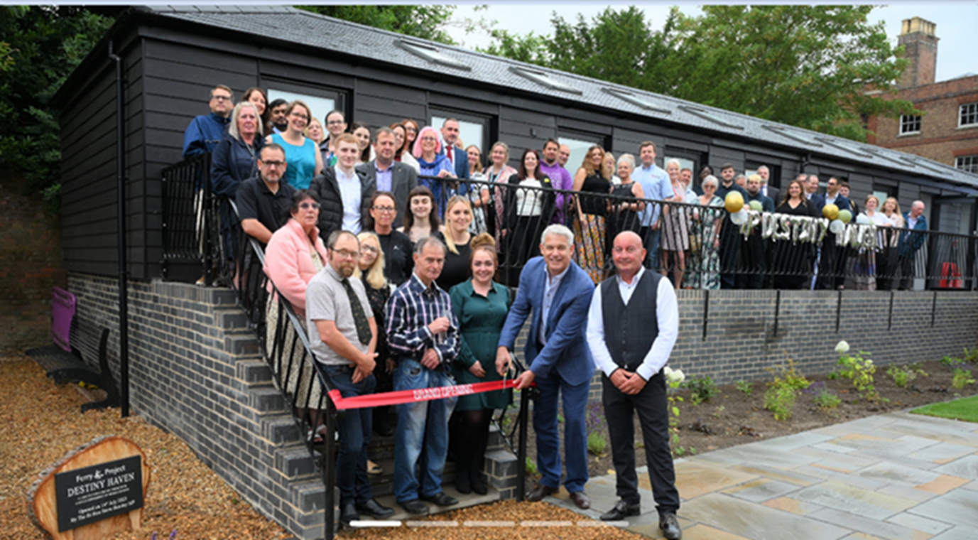

Case Study: Ferry Project emergency accommodation – Destiny Haven

F is a male in his forties and became known to services via reports from the Public of a rough sleeper in the Fenland area.

Fenland District Council’s Housing options team sent out an outreach team to urgently investigate and verify the report. The outreach team quickly located this gentleman and were able to gather an understanding of his circumstances.

F had become homeless following on from a relationship breakdown. Initially he had been able to stay in a garage adjoining his ex -mother in laws house. However, this arrangement had come to an end rendering him street homeless. F had worked in skilled positions prior to the breakup and had enjoyed success.

The impact of the separation had weighed heavily on him emotionally and had caused feelings of worthlessness leading to suicidal intent. During the periods of low mood, F had visited Beachy Head and been on railway tracks contemplating ending his life.

Through a quick analysis and appraisal, the Council’s Housing Options team were able to arrange a same day assessment at The Ferry Project’s Housing hub.

F was assessed by the Ferry Project team, who liaised with FDC to provide immediate accommodation for that evening and strategized longer-term outcomes around a bespoke plan tailored to F’s needs.

F met with the RSI funded clinical health nurse to meet his most immediate emotional health needs. The plan put together to support F included his own assessment of need and gave him assurance of what support services would be able to provide.
F was then brought into Destiny Haven accommodation at the Ferry project in order that the delivery package from the plan could kick in.

F was supported with transferring his GP locally to Wisbech and the onsite clinic made available. Access to medication and therapeutic interventions were able to follow hand in hand. To underpin his emotional wellbeing, regular access to the Rough Sleeper team was maintained and weekly appointments set up for F’s attendance scheduled in.

F also enrolled on to a wellbeing course available to residents at the Ferry Project.
At a time of his choosing, F started to help with voluntary projects around the Ferry site through the internal volunteering programme which he identified as giving him purpose and an ability to use his time meaningfully. F recognised that he wanted to ‘give back’, as a way of repaying the help that he was receiving and was pivotal towards building up confidence and self- esteem.

F was supported with access to benefits, and claims. The portfolio of services enabled F to gain self- confidence, clarity and certainty about his future and the possibilities and opportunities that could hold.

Over a period of time through contacts, observations and key works it became evident that both staff and F were noticing a positive change, and he became ready for the next step of his journey. F was then successfully placed into semi-independent accommodation closer to his children allowing him to rebuild their relationship.

By his own recognition F was lost and struggling to know what to do prior to the wrap round support that he was now able to access through FDC and other partner agencies. The interventions prevented potential hospital admissions, Police call outs in addition to a worst-case scenario of end of life.

F continues to live currently in Semi Independent accommodation and relies less on support as he continues his journey into total independence and a home of his own. He states he is looking forward to a fulfilling life and returning to paid employment, in addition to meeting other goals and aspirations that he is setting himself.

Housing First

Cambridgeshire County Council (CCC), successfully bid for funding from DLUHC under RSI 5 for Housing First provision in Fenland along with Housing Related Support funding from Cambridgeshire County Council. Housing First is intensive 1 on 1 support with clients who have very high support needs. To date there are 7 units under this highly successful programme, working in conjunction with Clarion and CCC Housing First team. Often Housing First clients are either rough sleepers or those at risk of losing their home and sleeping rough and have multiple disadvantages, meaning that traditional housing options are not suitable to enable clients to thrive.

Case Study: Housing First

CC has a long history of poor mental health, having been sectioned several times under section 3 of the Mental Health Act. CC has a diagnosis of schizo–affective disorder with depression and has been taking prescribed medication for a long time to help her to cope with this. Following a relationship breakdown CC mental health deteriorated and became unwell and set fire to her property. Following this she had a period of sleeping in her car before being placed in temporary accommodation.

A referral to Housing First was made and support was given to CC at this stage whilst in temporary accommodation. CC was supported to engage with Fenland District Council Housing Options Team and work towards making a homeless application and eventually being offered move on accommodation. Housing First Navigators were building a relationship and support included taking her out for coffee, food shopping, and supporting her to plan ahead; think about where she would like to live. Housing First also supported the work being done by the Fenland Adult Locality Team around confidence and self-esteem.

Clarion Housing Association accepted CC as a potential tenant, despite her having a historical arson offence. Housing First were able to work with CC to explain that this incident was related to her worsening mental health and with the support in place, this should no longer be a concern. After a period in temporary accommodation, CC was offered a tenancy in a sheltered scheme. Housing First supported CC by purchasing the basics required in a home such as Carpets, fridge, freezer, lounge furniture, a vacuum cleaner and microwave, as well as other smaller items. Support was given to set up direct debits for household bills and changes to her benefit claims to Universal Credit, enabling her to access financial support for her rent. Support continues with phone or face to face contact at least twice a week.

CC has successfully moved into her own tenancy and is managing well. CC mental health has been relatively stable, with the FALT team also reporting positive changes. CC is in a settled environment that she enjoys. CC has started to think about possible charity work locally as well as interest in art therapy with the FALT team. CC has recently received new reading glasses and is also considering joining the library.

Changing Futures

At the end of 2020, the government invited expressions of interest from areas who wanted to take a new approach to tackling multiple disadvantage.

Multiple disadvantage is where people experience at least 3 of the following 5 situations are said to be multiply disadvantaged:

- Homelessness
- Substance misuse
- Mental health
- Domestic Abuse
- Criminal justice

A Cambridgeshire and Peterborough multi agency collaboration applied and were one of 21 areas shortlisted. We submitted a full bid focused on extending and enhancing the approach taken by Counting Every Adult across more organisations in our area, so we can work together more effectively as a system to help people make their way out of multiple disadvantage.

It seemed that different organisations might easily conflict, not take account of the effect of the person having more than one “issue” and might not be adequately trauma informed. In other words, each organisation aims to help people; but by taking issues “one at a time” often end up not tailoring the actions to that individual person. Like fitting a square peg into a round hole. It’s not surprising that some people fall through the gaps, or give up, and end up encountering more disadvantage than they started with.

Our bid focused on learning from the past and building on that learning in the future; evolving our systems to improve outcomes for people, and reducing the number of people who fall into multiple disadvantage in the first place. A key feature of this work is to co-produce better systems by people with lived experience being involved in every aspect of the work, at all levels.

We submitted our bid but unfortunately were not successful. However with support from Cambridgeshire and Peterborough Public Service Board (CPSB) local partners have continued without government funding. Based on the evidence, energy and enthusiasm, leaders agreed to fund a “scaled back” Changing Futures Cambridgeshire & Peterborough programme.

There are four visions for the work:

- Embed the Trusted Person Model.
- Embed a trauma informed approach to support.
- Establish mechanisms to support shared learning and address identified barriers.
- Embed co-production and co design across the system.
We have engaged with individuals with lived experience and will continue to do so to enable services and processes to be designed to meet future clients’ needs.
One of the first successful cases was a Fenland case. The case study below highlights the value of collaborative working to achieve a safe and positive outcome for the client under Changing Futures approach.

Case Study: Changing Futures

The team involved were:

- Trusted person: Probation Officer
- Fenland’s Rough Sleeper team
- Care-coordinator at Cambridgeshire and Peterborough Foundation Trust (CPFT)
- Changing Futures trusted person co-ordinators
- Mental Health social worker
- Fenland’s dual diagnosis street team
Leon was rough sleeping in a public toilet in Whittlesey, which the council needed to close due to maintenance issues. Leon was not keen to move out but had no alternative accommodation.

Leon did not trust many people and avoided many appointments and interviews. He had a trusted person in his Probation Officer. This relationship helped access other support including arranging an interview with the GP in the toilet where Leon felt safe.

A mental health social worker became involved after requests were made to assist. This was a vital element of the success.

Missing an appointment led to a breach of Probation and then arrest. Arrest was planned out of Leon’s familiar area, so likely to be more traumatic. He would not usually have a Trusted Person present. There was the risk that the location of police station used might not help link with relevant local services.

Police enabled his trusted person to be with Leon when he was arrested so it is less traumatic, ensuring he was taken to a local police station so he could be seen by the local Liaison and Diversion (LaDS) service. Police prioritised his arrest so he was somewhere safe and could start to get the support and help he needed.

During Christmas and a cold snap Leon agreed to engaged with Ferry Project for accommodation and support. Information relating to his support needs were shared quickly between the partnership. A mental health assessment was undertaken with his trusted person (Probation Officer) present.

Whilst assessments were undertaken to source suitable accommodation, the Council accommodated Leon in temporary accommodation. Despite this being offered numerous times, this time he accepted.

Due to Leon’s anxiety, the first visit to specialist supported accommodation did not go well and he refused it. Temporary accommodation was extended by the council whilst alternative solutions were explored by the partnership.

Leon viewed the placement and described it as a posh hotel! He was very happy with it and happy to move into his new home.

Comments from partners involved include:

“Just to update you that Leon has moved to the placement as planned. He appeared cheerful and excited. Thank you all for the support you have provided to Leon over the months.” Changing Futures Trusted Person Coordinator.

“Such fabulous news.” Care Coordinator at the Mental Health Trust (CPFT)

“This is brilliant news! Glad he has somewhere to call home and wish him lots of luck.” Fenland Rough Sleeper Team.

“Oh fantastic news, has he got everything he needs? Thank you for all of your hard work, you have been amazing.” Probation Officer.

“Leon just popped to the probation office to see me of his own accord which was good of him. He seemed really well, is happy with the move and he was off to ASDA to buy some pots and a bit of food. We agreed to keep in contact weekly while he gets settled in. All seems to be well.” Probation Officer.

“Can I just thank everyone for the massive collaborative effort in pulling this person back from the brink and into suitable stable accommodation where they now have a fantastic opportunity to rebuild a life. Testament to the power of partnership working. An officer mentioned to me that Leon was the best that they had seen him yesterday. Well done all.” Fenland District Council.

Impact of the Covid Pandemic

The council were in a fortunate position that we were (with our partners), delivering Rough sleeper Initiative 4 (RSI 4). In effect, we already had an infrastructure in place with which to respond to the pandemic and our rough sleeper co hort. Our approach did however require new delivery methods and broader partnership work with Clinical Commissioning Group, Public Health and various government departments who monitored our vaccination take up and number of rough sleepers brought in under an initiative called Everyone In.

Initially 57 rough sleepers were housed, this included the Ferry Project Night Shelter clients, most of the clients were accommodated in two locations within Fenland.
Clients were provided with weekly food parcels, mobile phones, very regular contact from rough sleeper outreach who adapted their service to suit the new circumstances.

To encourage vaccination take up a partnership including Environmental Health Team, RSI 4 team, NHS and the Terence Higgins Trust, was developed including an event to screen for sexual health. Alongside this NHS vaccination staff were on hand to talk through vaccination hesitancy with our clients and offer the vaccination at that time if they wished to take it up. We offered £10 shopping vouchers for this purpose which was very successful.

In total, between 2020 – 2022, the RSI team rehoused 134 rough sleepers.

Key challenges arising from the strategy review

Current and future challenges

As an organisation we have been able to increase interim temporary accommodation that is not B&B. Not only do we have the usual mix of households approaching; with Homes for Ukraine sponsorship funding ceasing, we anticipate an increase in approaches from these households. The discontinuation of hotel accommodation for Afghan households is further demand identified. We are therefore currently investing in the purchase of 33 properties via two tranches of Local Authority Housing Fund, 20 for general needs homeless properties, 8 for Ukrainian households, 5 for Afghan households. The properties are spread across the whole of Fenland, with only a small number of general needs in the town of Wisbech where historically we have had the most provision. Once Ukrainian and Afghan cohorts are moved into permanent accommodation these units will become general needs.

Even with the Local Housing Allowance rate increasing from April 24 it is not keeping pace with market rates which is leading to more households facing affordability issues.

There is also an increase in landlords disposing of their portfolios as a result of economic challenges and increased regulation coming in the form of the Renters Reform Bill. This is decreasing the pool of private sector properties available which leads to further price inflation as competitiveness increases.

Agents and landlords are also able to be more selective over prospective tenants.

Key challenges

- Demand for service increasing – more people are contacting us for housing advice in the past 18 months (post covid).
- More clients with complex needs are contacting us for help, resulting in the need for the provision of homes with high support provision e.g. specialist drug and alcohol.
- A significant increase in cases of domestic abuse.
- Larger families - larger properties are needed to be built to prevent families spending longer time in temporary accommodation whilst waiting for a large enough property.
- Engaging with private rented sector (PRS)– to offer solution for customers, landlords selling up resulting in greater reliance on social tenancies.
- Reduction in social housing tenancies available – resulting to families/individuals spending longer in temporary accommodation.
- Reduce HB subsidy implications for the council to support the medium financial strategy.
- Cost of living crisis continue to have a HOT service that can respond to further pressures arising from the cost of living.

Core aims and commitments in the strategy

Links to Corporate Business Plan

The Council’s Business Plan outlines our focus around communities ‘we will use our housing powers to prevent homelessness, reduce rough sleeping, meet housing needs, improve housing conditions and keep homes safe and accessible’.

Homelessness prevention

The ambition and focus for the council are to prevent homelessness wherever possible. This involves our teams being creative, flexible, and working together with partners to achieve this. The benefits to prevention are multiple, including the impacts on health and wellbeing, education and employment and mental health.

Reducing / stopping the cycle of homelessness and sustaining futures

We have invested part of our RSI5 funding into tenancy sustainment. These services are delivered by CGL and Ferry Project. We work hard together to find suitable pathways for our clients. This has been hugely successful thanks to NSAP & RSAP funding from DLUHC, working with Amicus & Ferry Project & Clarion to increase the number of supported placements within Fenland.

The transition from street to emergency accommodation can be daunting and very challenging for some clients. We have invested together with the Ferry Project for a temporary arrangement with Bunkabins (a temporary portable structure delivering a self-contained living unit with facilities to live independently). They enable the time for ‘decompression’, a safe place to be and transition from the street to a safe and supported space.

When moving on from Ferry Project’s emergency accommodation (now known as Destiny Haven – 9 self-contained units) it’s imperative that tenancy sustainment forms part of the move-on process. This has been integral to our RSI 5 work and has achieved 43 successful results since the start of the project. (June 2023 - March 2024).

Working together

We are incredibly fortunate to work collaboratively with ambitious and experienced partners who are an integral part of our quest to eliminate rough sleeping and homelessness in Fenland.

People who are homeless don’t just lack a home, there are often many other contributing factors such as their health and wellbeing, finances, substance misuse, life choices and relationships. Homelessness impacts on virtually every element of our lives, our health, education, work and our ability to find work, personal safety etc.

Working together effectively as one team is the only way we can tackle these issues together in Fenland.

Delivery and monitoring

Action plan overview

The aims and commitments contained in the strategy have been captured in our action plan and forms part of the entire strategy document. The actions are clear and there is accountability for each one. Results from the consultation will be included.

Monitoring and review

We will review the plan regularly with partners to ensure that the actions stay on track, are progressed and remain current and relevant. We will do this through a review of the action plan each year as part of the Councils service planning process.

