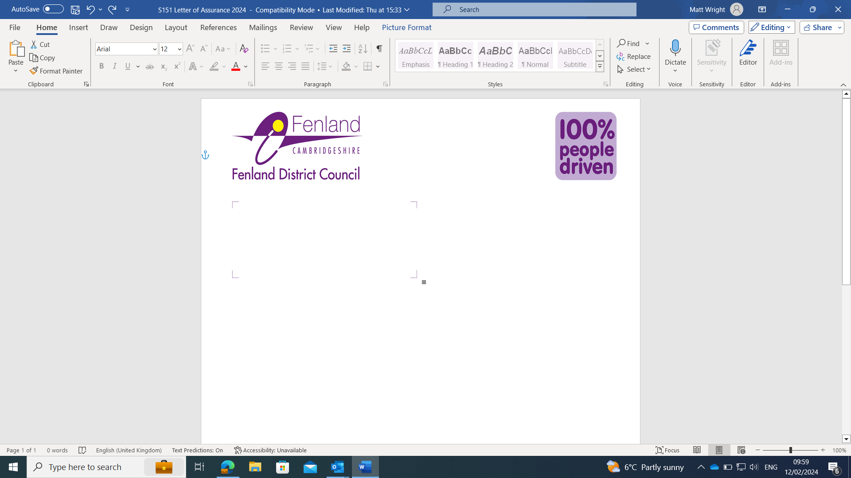
Agenda - Wisbech Town Board

Private Meeting – invitees only

October 7th 2025, 18:00 onwards – Wisbech Town Council Chamber

Invited Attendees:

Town Board voting members:
Local Community representatives;
Chair - Iain Kirkbright
Vice Chair – Cllr Chris Boden
Amanda Scott
Louise Pitt
Paul Faulkner
Oluwafemi Okanlawon
Richard Scott

Member of Parliament Stephen Barclay
Cambridgeshire Police Superintendent Ben Martin

Fenland District Council Member Cllr Steve Tierney
Wisbech Town Council Member Cllr Susan Wallwork
Serving Member of Cambridgeshire County Council Cllr Samantha Hoy

Non-voting members:
Supporting Fenland District Council Officers:
Head of Corporate Support Jo Blackmore
FDC Lead Simon Machen
Programme Manager Matt Wright

Chair:
Iain Kirkbright

Vice Chair:
Serving Member of the Cambridgeshire and
Peterborough Combined Authority Cllr Chris Boden

Agenda:
Item: | Description:
- Welcome
- Declaration of Interests | Members to declare any outstanding interests within the town for notation on the Register of Interests.
- Review of Minutes and Actions from the last meeting | Review and accept previous minutes, to be published.
- Town Board Financial Update | Financial update
- General Programme Update | - Website  - Wardens  - Surveys and Valuations (Confidential)  - Submission  - Consultation
- Governance arrangements Report | Officers to outline the wider governance process undertaken around Board Decisions for Info.  Presentation of standardised project request pro-forma.
- Regeneration Plan and 4 Year Plan document review and approval | Discussion and amendments to proposed Regeneration Plan and 4 Year Investment Plan  Approval for submission subject to any outstanding amendments  Vote
- Upcoming deadlines | Wisbech Town – Consultation October/Early November  Wisbech Hudson Leisure Centre – Consultation October Early November  Online Consultation Via FDC comms: October 23rd onwards  FDC Endorsement – Cabinet Report 7th November  Submission of Documentation – Following Endorsement and Consultation Conclusion, (Nov 10th Target date)
- AOB
- Date of next meeting | TBD – Frequency to be reduced to Quarterly until feedback received from Government.  – Next meeting proposed for New Year  Ad Hoc meetings with relevant parties as required relating to ongoing capacity funding spend.

